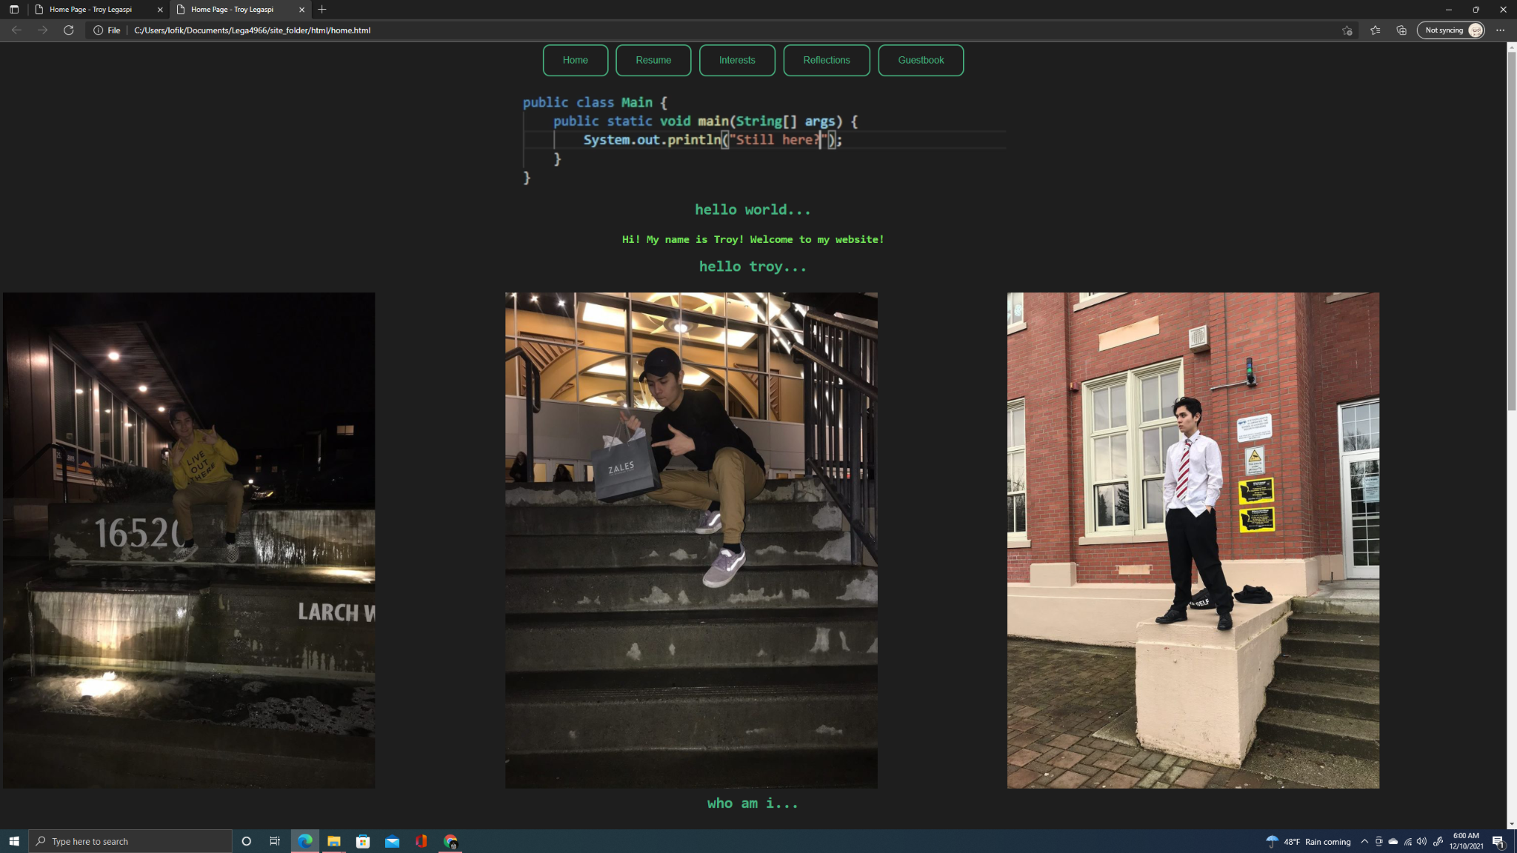

Homepage for the website. The top banner always contains links to every other page. There’s a banner video that’s a homage to the famous “Hello World”. This one was written in Java. The colors for the website are actually inspired by the colors in Visual Studio. I manually color picked them from screenshots to make sure it was accurate. This homepage has some pictures of me and my pets, as well as some information about me.

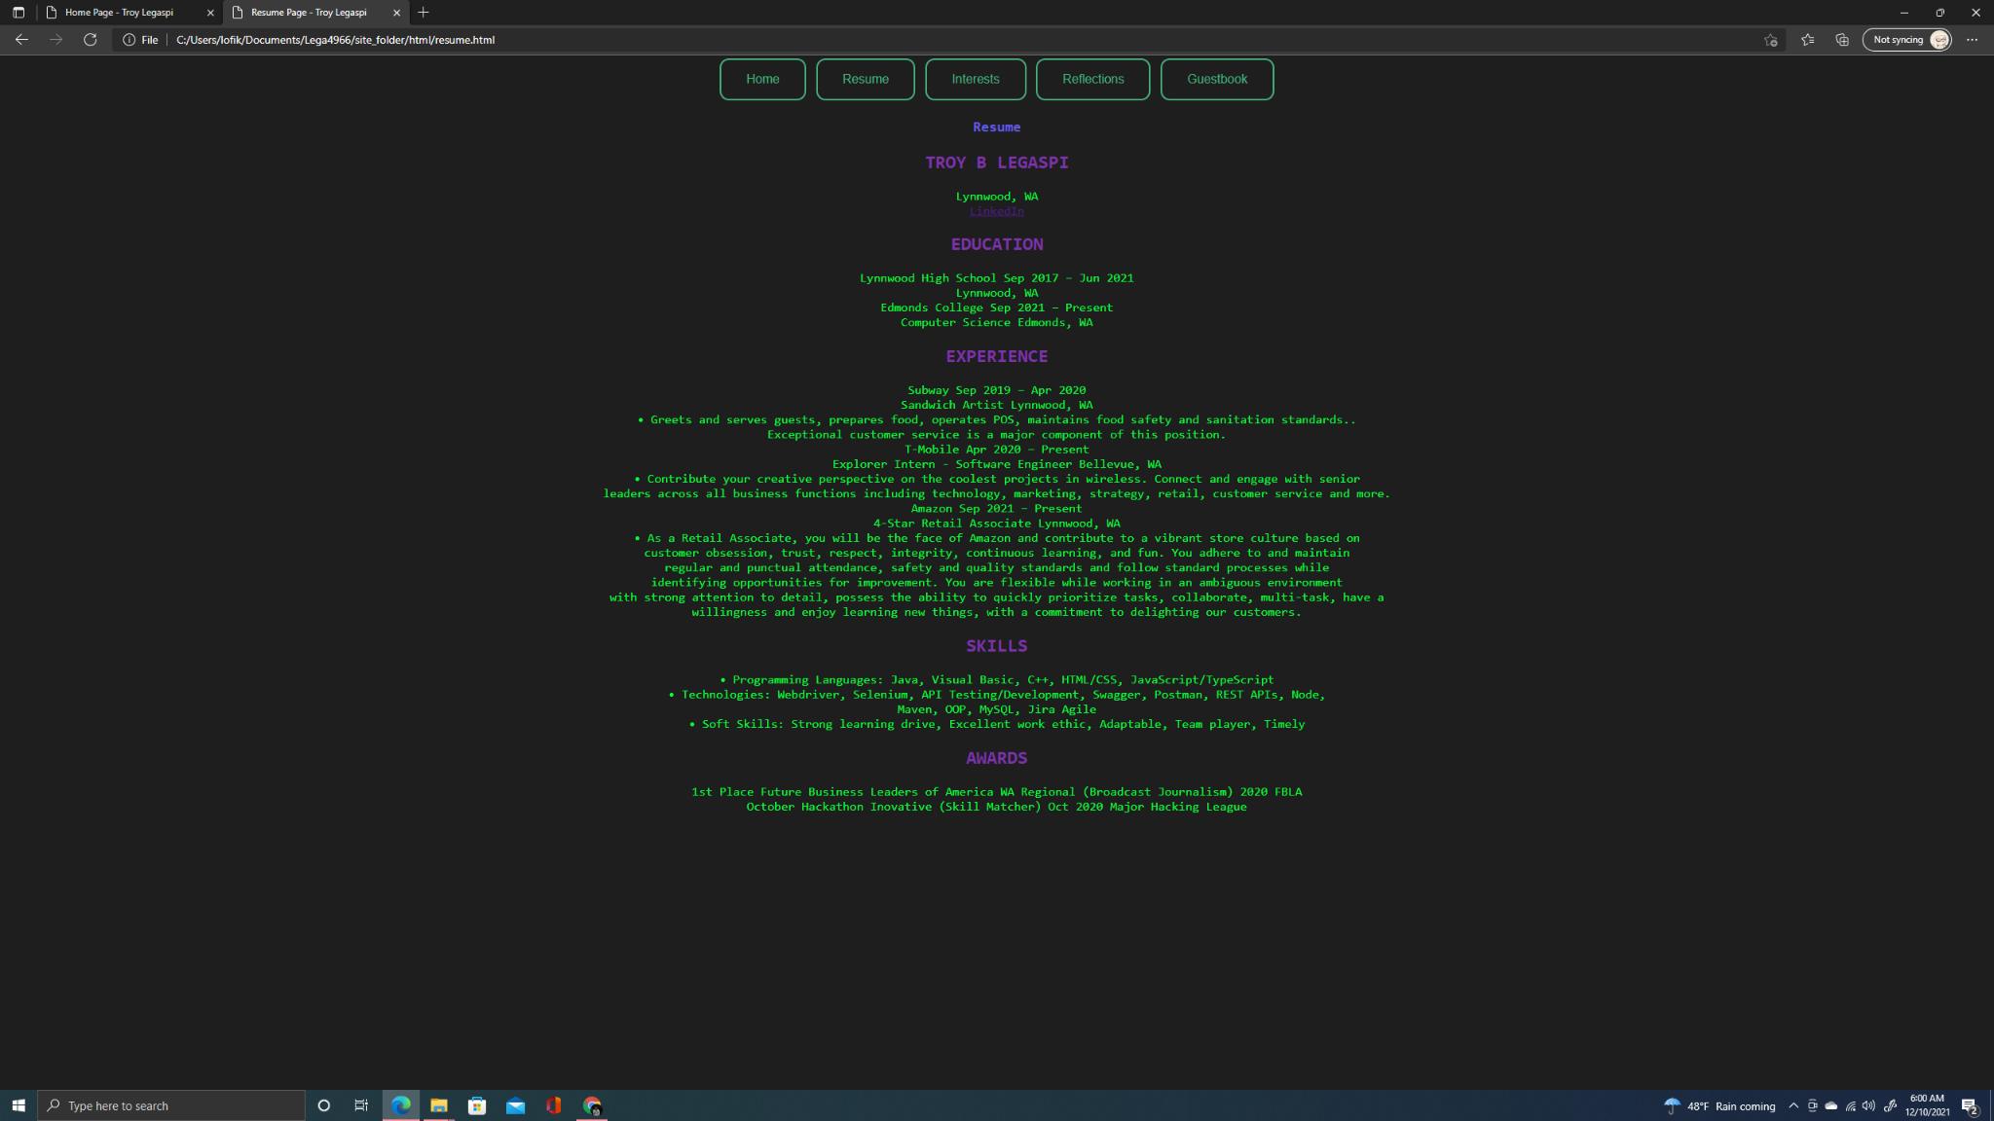

This is my resume. As always the topbar contains all the links to navigate to other pages.

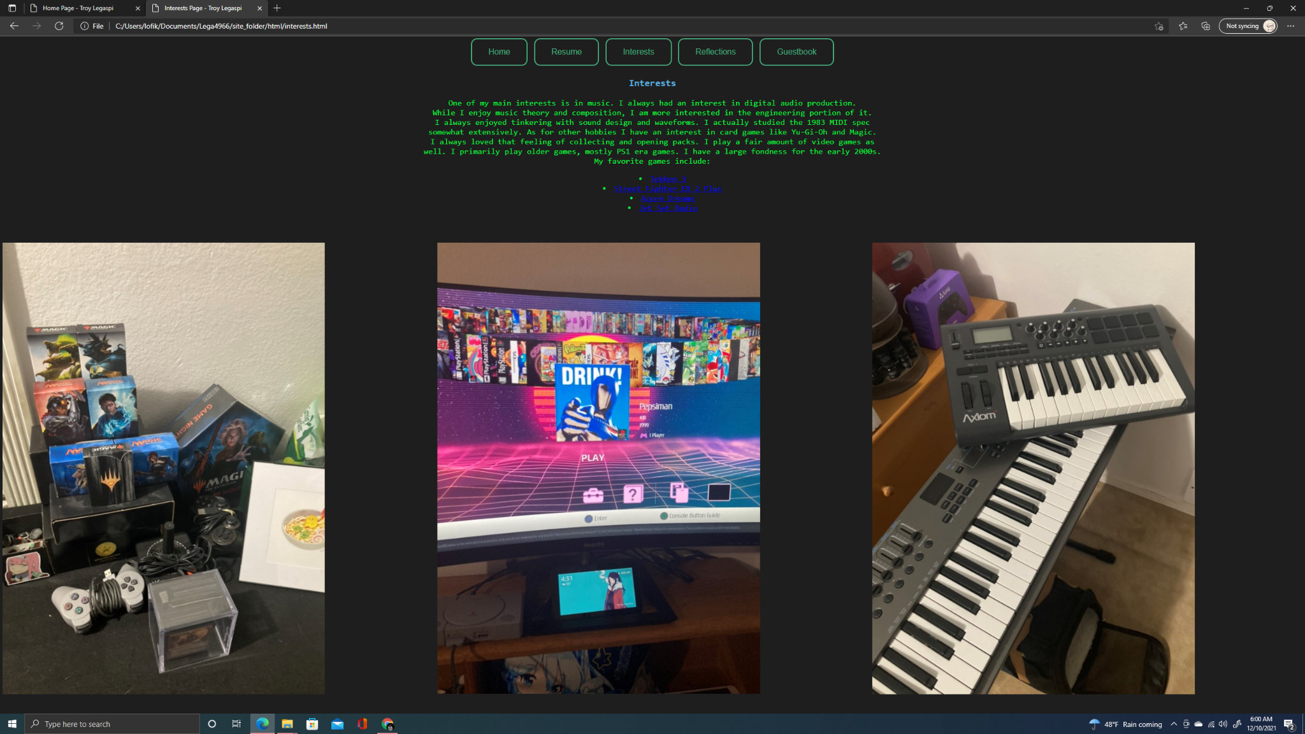

Some of my interests are listed here. There’s links for my favorite games, as well as pictures of my main 3 hobbies.

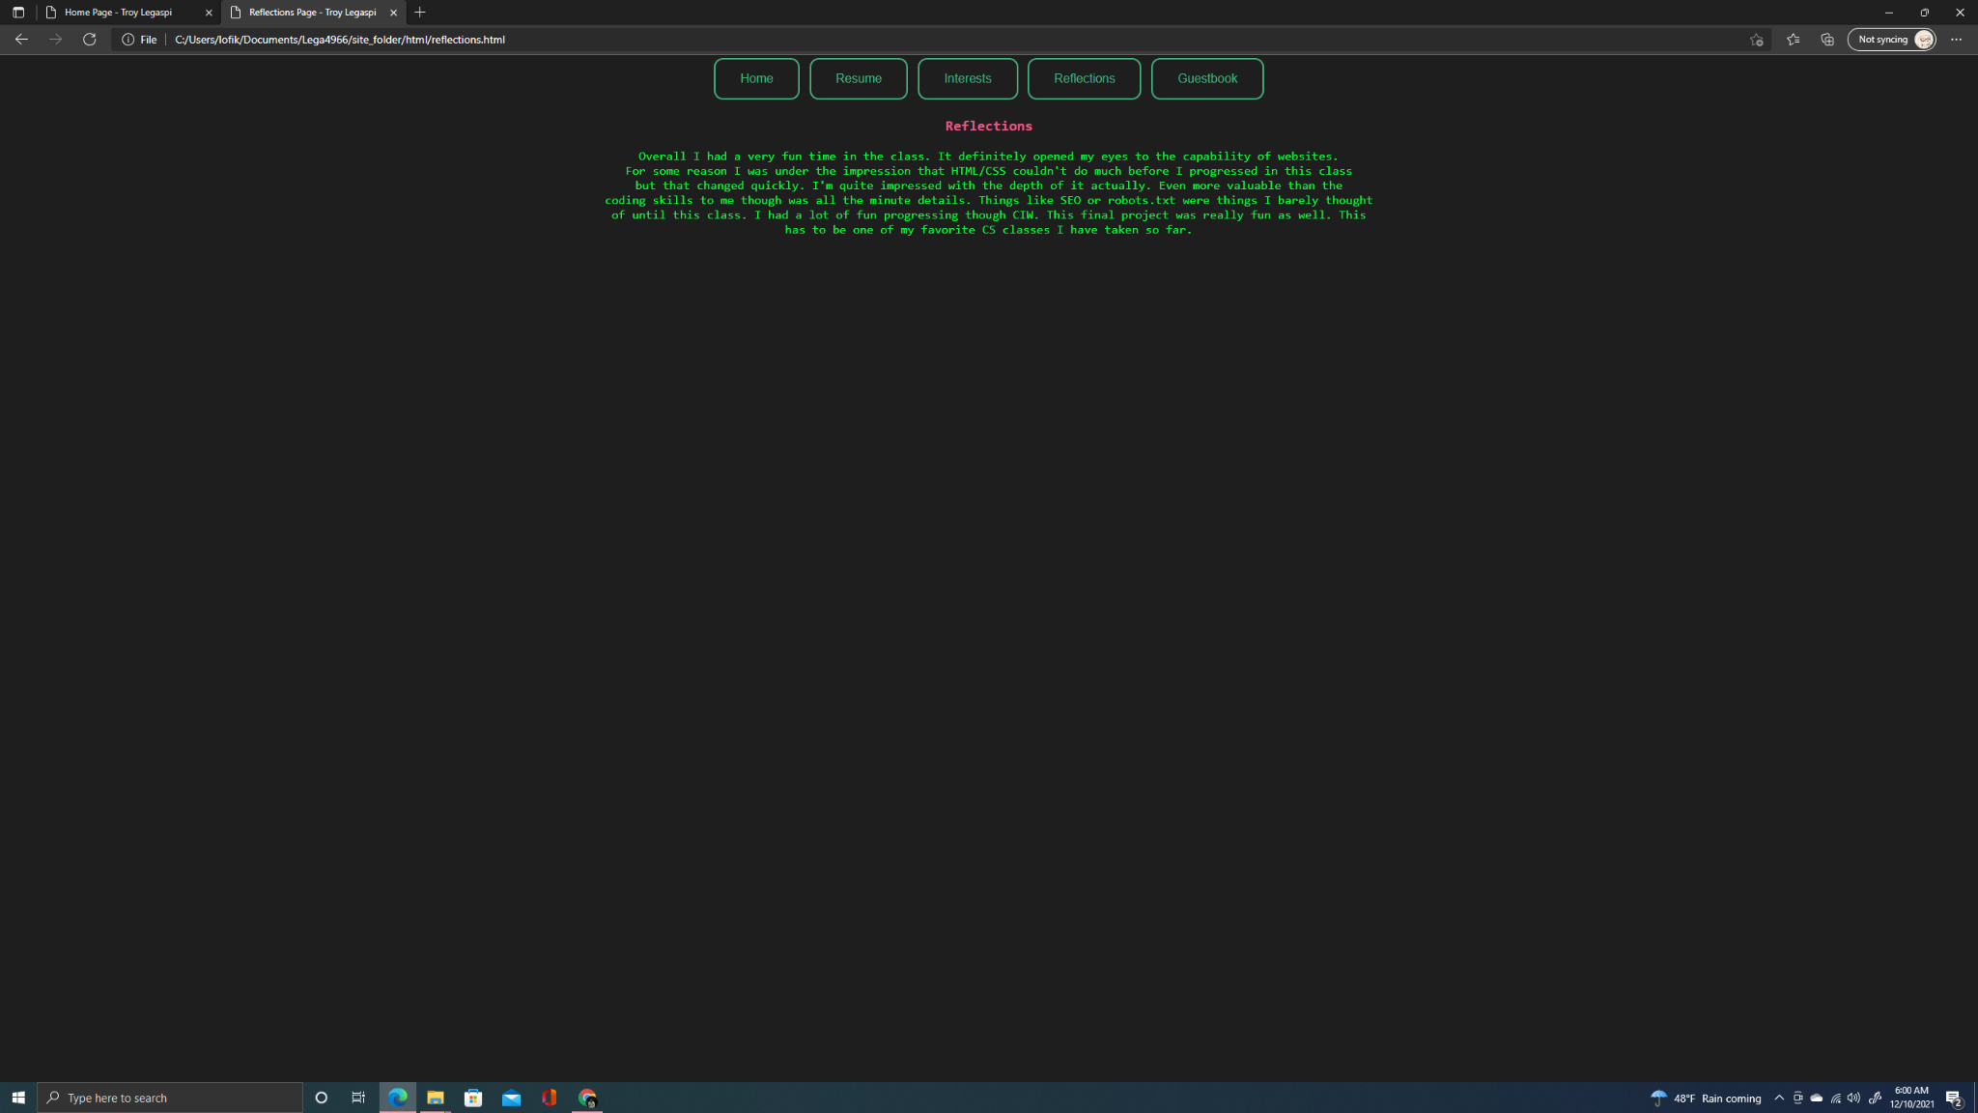

This page contains my reflections for this class and quarter.

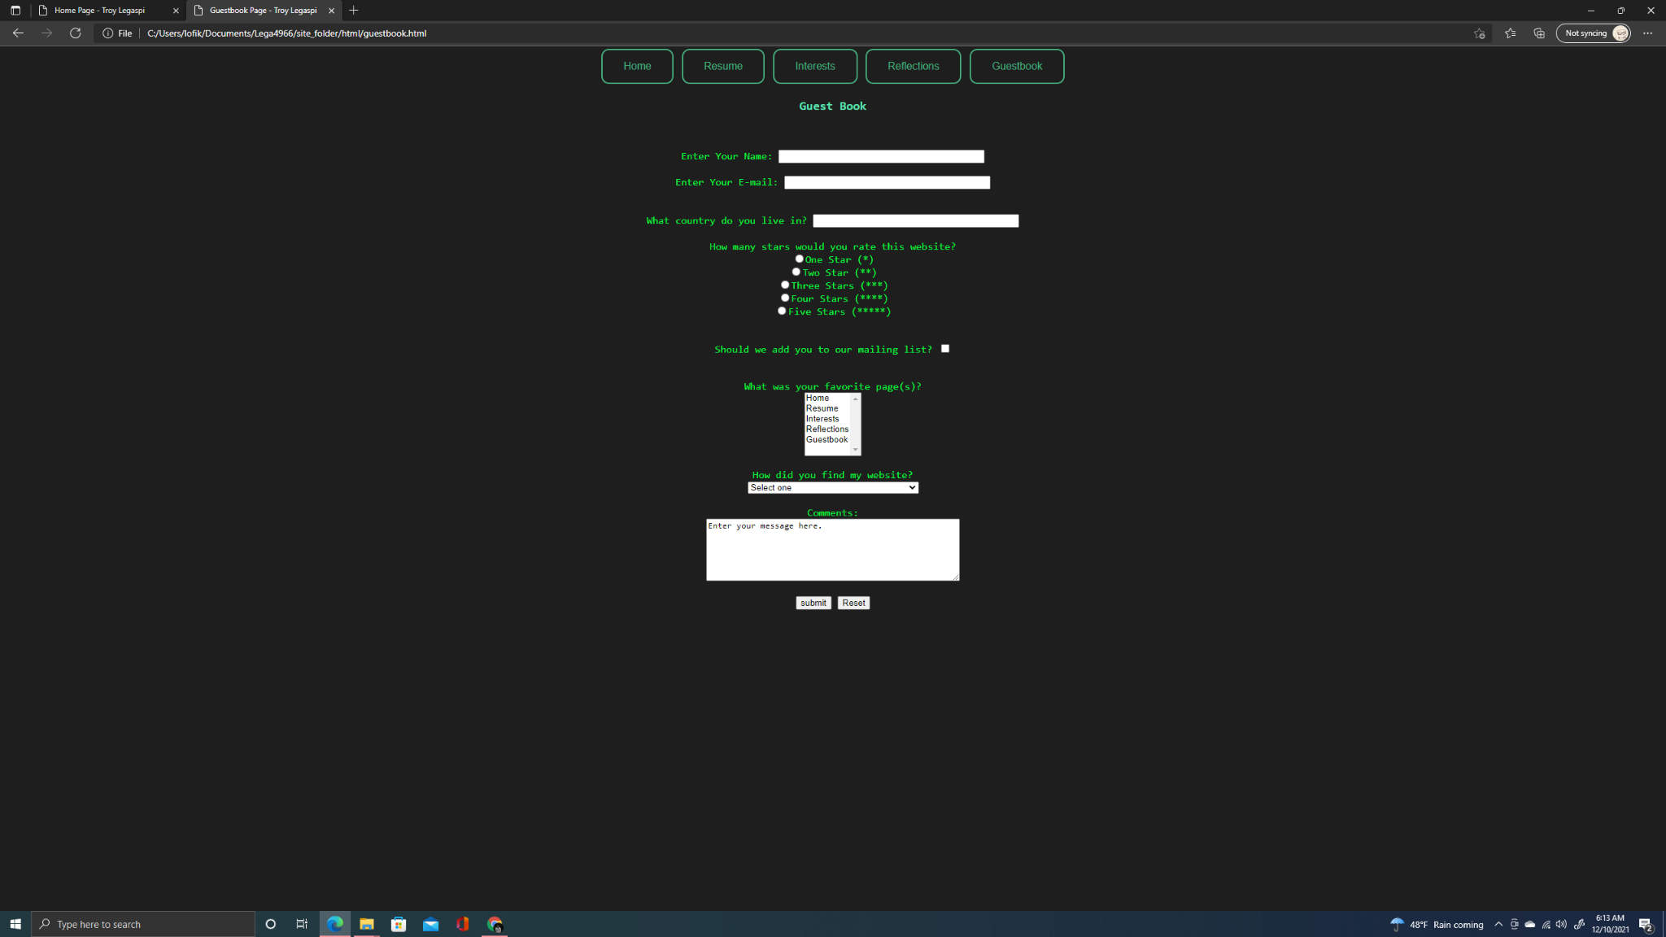

A basic web form to serve as my guestbook. Here you can fill out a survey of how much you liked the site or to be added to my non-existent mailing list!